DIGITAL MEDIA AND THE RISE OF ETHERNET STORAGE TECHNOLOGY
There’s a new paradigm in digital media technology. Ethernet is no longer just a way to transmit raw data and files. Ethernet will dominate the creation and distribution of content with the direct transmission of video signals over Ethernet protocols. This shift to Ethernet switching and transmission will revolutionize content creation.

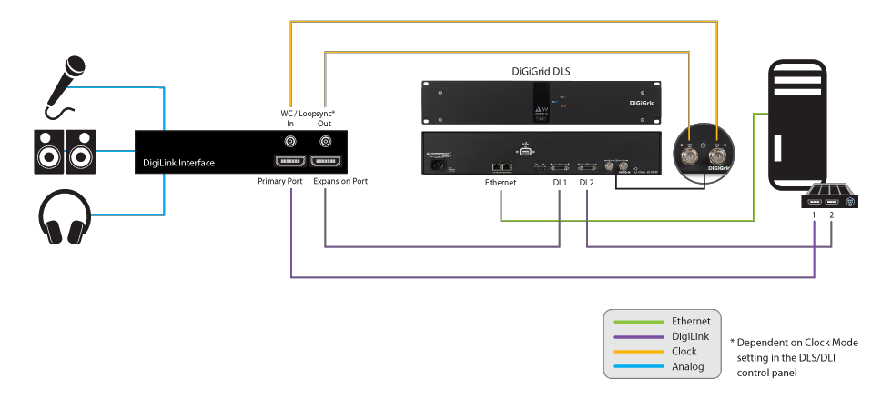
Networking of a studio

Ethernet infrastructure is redefining the studio. Switches, servers and storage are the keys to this new studio. Software will become the switchboard, Ethernet switches will be performing as video routers. Networked storage is at the heart of this change and is at the center of the infrastructure.

Currently there are two forms of network storage used for collaborative media workflows, a Storage Area Network and Network Attached Storage Both enable creative teams to work together on the same media, supporting greater productivity, less risk of media loss and the delivery of a better product. However, the paradigm shift is enabling a far greater number of digital video professionals to participate and deliver the high quality content demanded of consumers today.

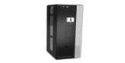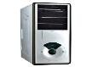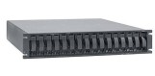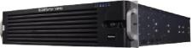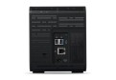

Storage Area Network

SAN, PAST ITS TIME?
SAN has historically been used by facilities with demanding workflows because it was one of the first network storage technologies. It was also fast, relatively speaking, and supported editorial workflows. It started with 1gig and now the connection tops out at 16gig. With this speed you can understand why creative professionals have looked to SAN technology for media workflows.

Separate server for Metadata
Additional hardware and software required for basic GigE connectivity.

Two networks required to support most SANs

Beyond the respectable performance, storage area network technology scores poorly when it comes to flexibility and ease of use. Taking a closer look at SAN technology, one must first realize that they are based on block level protocols like Fibre Channel (FC).

This protocol has a high level of complexity. For example, FC requires storing the metadata (file system) separate from the data and, thus, demands two networks - an Ethernet network to provide the metadata access and a Fibre Channel network to provide the data to the clients. Additionally, many SAN systems require separate servers to support the backup of the metadata, further increasing complexity and cost. Adding to this is the fact that there is no way to bond ports for increasing bandwidth. The only way to use two FC ports is to create a stripe across two sets of storage each with a different fibre channel port. This is no easy task and certainly requires significantly greater effort to get the necessary bandwidth.

Then there's the challenge of providing low cost Ethernet connections to clients.
Not all SAN’s have the ability to use the metadata network to serve out volumes. So SAN’s typically requires additional hardware, software to serve out volumes. This increases cost and reduces Ethernet performance.

ETHERNET VS. FIBRE CHANNEL PERFORMANCE
With recent advancements in Ethernet based storage technologies, the performance of Network Attached Storage (NAS) systems cannot be overlooked. There are two metrics to consider, latency (IOPS) and bandwidth (MB/sec). With all of the advances in IP technology, the overhead of TCP/IP is a non-factor relative to SAN. Improvements in PCI technology, faster chip sets and Ethernet based protocols have NAS latency at identical or lower rates than SAN. Bandwidth is easier to compare. The maximum FC speed is currently at 16 Gigabit per second. In comparison, most NAS connections are at 10GigE today, with plenty of server (and switch) connections at 40GigE. And, NAS has already started to deliver on 25, 50 and 100 GigE speeds,

Furthermore, 32gig FC speeds actually run at only 28 Gigabits per second due to a holdover from 8/10 encoding from early FC. Comparing 32 Gigabit Fibre Channel and 25 Gigabit Ethernet, they provide nearly identical throughput.

- 25 Gigabit Ethernet raw throughput: 3125 MB/s
- 32 Gigabit Fibre Channel raw throughput: 3200 MB/s

ETHERNET WINS THE RACE
Network Attached Storage technology has clearly outstripped the bandwidth of Storage Area Network technology. 10gig, 25gig, 40gig, and 100gig HBA’s are now available with the switch infrastructure to match. Additionally, the simplicity of Network Attached Storage has a direct effect on the performance as well. The ease of port bonding and adding a faster host bus adapter (HBA) or NIC enables greater throughput to editing systems and switches. One also needs to take into consideration that there is no metadata required to figure out who has permissions for what data.

SUPPORTING 4K
The HD 4K format is getting increased momentum as a favorite choice in the broadcast and entertainment sector today. Video professionals are faced with new performance demands as a result of 4K growth and, invariably, are embracing the advantages of 4K. Even the most demanding 4K raw files can now be played out just as well on a Network Attached Storage because of the improved bandwidth and flexibility described above. Consider, for example, the playback of Sony 16-bit RAW 4K-Full 60 frames/sec (at 849 MB/sec). A single 10GigE connection has the ability to manage this. An additional benefit of NAS technology when comparing to storage area network is the scalability. 4K files are big and adding capacity, as well as bandwidth, is very important. NAS technology can efficiently support this level of scalability.
THE ETHERNET AS THE BROADCASTER
Storage Area Network and Network Attached Storage can both deliver digital video, but only NAS can directly do it to the Ethernet and to Internet directly. The rise of the Internet as a major delivery platform for entertainment has made it clear that content creation should be done over Ethernet.

Storage Area Network systems will get more and more difficult to integrate in the new paradigm of digital media technology, while Network Attached Storage systems will get easier. There are very few FC switch manufactures and they do not play well with others. Broadcasters are switching video over Ethernet switches now.

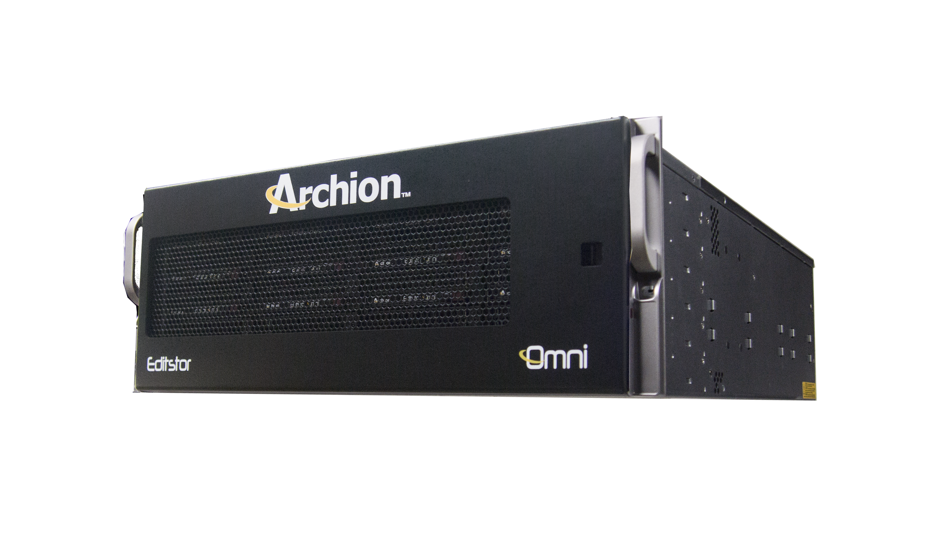

ARCHION DELIVERS
Archion is a dynamic software and hardware manufacturer dedicated to creating storage that lives in the information technology (IT) world but excels with all the tools of content creation. Creative applications such as Adobe Premiere Pro, Avid Media Composer, Apple Final Cut Pro, Blackmagic Resolve and others are comprehensively supported.

EditStor Network Attached Storage systems are completely based on Ethernet protocols. They are storage and server all-in-one. Tconnections are Ethernet so it has more flexibility and simplicity than Fibre Channel. The protocols are all common standards based such as SMB, NFS, and AFP and all are supported for optimum performance. Editstor is flexible with virtual volumes that are easily expandable, and with built in management of resources. In addition you can scale easily, adding more storage to the system without downtime. The infrastructure is Ethernet, so switches, cables, and HBA’s are robust and easily connected for high-availability and you only need one NIC or HBA to connect at speeds up to 100gig or more.

In 2015, Archion introduced significant bandwidth increases that challenged SAN technology. In under a year, Archion was able to leverage advances in NAS and storage technology to double that bandwidth. EditStor Omni is now capable of 8000 MB/sec.. This improvement significantly enhanced true collaborative 4K workflows with the ability to connect different systems such as Mac, Linux and Windows without any special software.

Editstor file systems are designed with high resolution workflows in mind. The systems write files sequentially so that DPX and other frame codecs work easily. With EditStor today, you can connect client systems directly or through a switch with 10GE or 40GE. All content creation tools, including Adobe Premier Pro, Avid’s, Final Cut Pro X, Resolve, are supported. The standard based protocols allow ease of connection and full compatibility. Archion systems have the tools for transparent Avid Project sharing and Final Cut Pro X libraries and Projects. Resolve projects and Adobe CC are also supported with Archion’s Collaborate server.

Archion is dedicated to creating the best collaborative storage solutions to support all audio and video workflows, including more demanding ones such as 4K, 5K, and beyond.

SUMMARY
The whole Internet is becoming one large broadcaster. The content creators need storage that can interface easily with high speed to the network. Ethernet is a data transport that can transmit any sort of data. From file based data, ISCSI and digital video, the Ethernet is so flexible that it will be the infrastructure that will deliver 4K, 5K and the next generation of video.

Information Technology has touched every sector of our economy in tremendous ways and remains inevitable. The amount of data moved throughout the broadcast and content creation facilities is growing rapidly around the world. If you are looking for a proven technology and service organization to rely on for the future of 4K and beyond, look to Archion. With 17 years of experience building leading shared storage technologies and our comprehensive knowledge of IP infrastructure, we are dedicated to delivering the best NAS based media storage products and solutions.

